***Name : HIMANSHU DIXIT***

***Enrollment Number: B64178***

***Batch: B10***

***Experiment No : 7***

***(Angle of Prism)***

***Aim:***

*To determine the angle of the given prism.*

***Formula Used:***

|  |
| --- |
| A= θ/2 |

*Where,*

*A is the angle of prism.*

*θ is the angle between two reflected ray.*

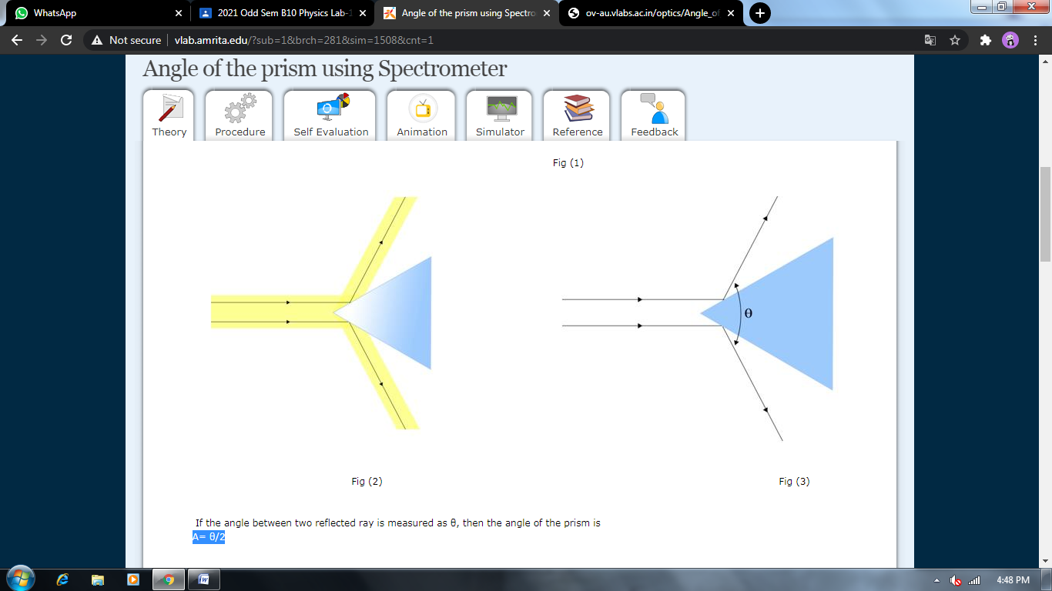

***Obesevation table:***

* *Least count of scale is 1/60.*

|  |  |  |  |  |  |  |
| --- | --- | --- | --- | --- | --- | --- |
| ***Face*** | ***Vernier 1*** | | | ***Vernier 2*** | | |
| ***MSR*** | ***VSR*** | ***TOTAL*** | ***MSR*** | ***VSR*** | ***TOTAL*** |
| ***AB*** | *191.133* | *0.166* | *191.299* | *129.5* | *0.15* | *129.65* |
| ***AC*** | *69.5* | *0.133* | *69.633* | *249.5* | *0.116* | *249.616* |
| 2θ |  | | *121.666* |  | | *119.966* |

***Calculation :***

2θ1=121.666 , 2θ2=119.966

θ1=60.833 , θ2=59.983

A= (θ1 + θ2)/2 =(60.833 + 59.983)/2= **60.408** degree.

***Result:***

*The angle of the prism is = 60.408 degree.*

